**ENGLISH**

**USER INSTRUCTION MANUAL**

**OneStim-CRM**

**Cardiac Stimulator / Recorder**

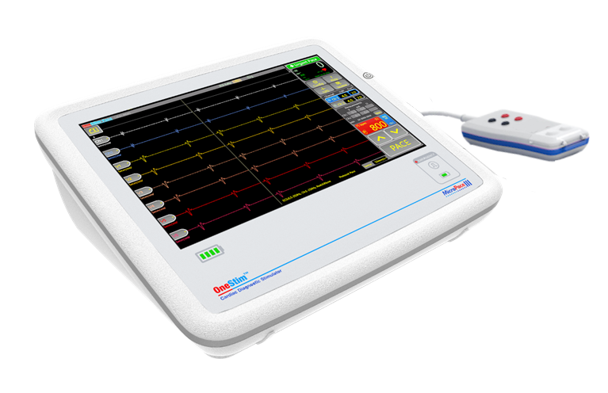

Amendment Control

|  |  |  |  |
| --- | --- | --- | --- |
| **Vers** | **Date** | **Pages/ Sections Changed** | **Who** |
| 4.0 | 1.12.23 | Added All to 8.1 trigger page, clarified Template explanation, cleaned up some diagrams, and labelling.  Change length of MP4118 from 3.0m to 5.0m | MC&QX |
| 4.0a | 10.2.24 | Added W9.1 Do not stim into RFA, because was in EPS320 UIM (Later removed) | MC |
| 4.0b | 22.02.24 | Added ‘UIM’ help symbol on page 2 5.3 PACE Mode Main Screen –Updated the screenshot with filter/unfiltered option and impedance graph  6.1 Setting up ECG Sources for display – Updated the screenshot of the ECG trace selection dropdown list and added the unfilter/filtered comparison screenshots.  9.2 Help Menu – updated the UIM symbol | QX |
| 4.0c | 24.2.24 | MC: Sect. 6.1 – changed Filtered/Unfiltered to actual traces, 24.2.24  Remove W9.1 at 4.0a, because Clinical Paper allows – see DC-UIM  Please add future changes to D\_UIM Change Control x.x.docx  **Released at V4.1** | MC |
| 4.1a | 28.3.24 | 9.2 – Updated UIM symbol  Page 2 - Removed OneStim: Help button  10.3 – Fixed USB format sentence for English UIMs only. | JG |
| 4.1b | 4.4.24 | Fixed images overlapping text in 6.3.2, 9.2, 10.3 & 15.4.  Added HMDI cable to explanation of symbols in section 16 – Video Display | JG |
| 4.2 | 5.4.24 | **Relelased for distribution - Model UIM’s are at 4.1 !** | RG |
| 4.2a | 15.05.24 | PCO24-014 MP4140 description has been changed to HDMI Male to DVI Male Cable 10M, updated section 4 – optional with the above description | DP |
| 4.2c | 31.5.24 | Made MP4138-HDMI Male to HDMI/DVI Male Cable 5M and MP4140 same but 10m  Added into file Yellow editing instructions – find and deleted them before publishing  Added Yellow Instructions to Delete redundant Tables (no way to do using just colours)  Added Table label for Contents and Optionals tables (but not List of Tables – only 3  Corrected Specifications Channels by adding Pace and EP Mode, so is correct in DUO  Sect 7.4.2 Threshold Protocol figure - changed Purple colour to Grey (confusing)-minor  Sect 9.2 Help Menu – Added Help Icon | MC |
| 4.2d | 1.6.24 | Figure 6 Fixed label misalignments – placed it and Fig 8 into Graphic box  Added to Fig 4 Trans-venous electrodes (+Translate)  Added to S4.6 – Pace Mode - Connect ECG Leads  Added to S6.3, - Pace Mode: 1.Press Trigger button then the QRS button (+Translate)  S1.1 Added “two or” and changed 8 to 14. (+Translate)  Figure 3- fixed and updated with HDMI cable, Grounding, USB Key  **Action** – for next UIM printing or before next translation :   1. Remake the 4 Model UIM’s / or manually fix 4.2a to d 2. Manually fix 4.2a to d in translations. | MC |
| 4.3b | 20.06.24 | Based E\_OneStim Technical UIM 4.3-ALL generated by MC on 01 June 24  Added in instructions STIM Mode – RED text, added to Green EP mode  Added Red text: 5.2 and S7.4 More Pacing protocols  Added to Fig 4, trans-venous electrodes  Added Red text 7.4.7 Bi-Ventricular  Added Red text 7.4.8 HFS picture  Aligned with R\_Gap between 4.2d CRM and 4.1 CRM v0.2  Section 1.1 Added (dependant on the model) after two or four channels  Section 2.7, para 2, changed from 6500 to 6100 to align with CER  Section 9.2 – brought example with H175 back  Section 12 – Moved brown text down and leave Config Menu picture and text above the brown text and in black text  Make changes per R\_UIM Review MC 0.2  9.2: Move “Press the Book Icon…” sentence to below Help Text Picture  9.2 Changed “help icon”, Added in CRM-S1Mode and MEP—S1 Mode  10.1 Removal of “for 1 second” from “touching the electrogram feature for 1 second’  10.2 Changed ‘allow’ to ‘allows’; removed “of” in “of traces”  Source: E\_OneStim Technical UIM 4.3b  Added 9.1-MC/RG Config Menu with “Config menu can be protected by enabling password (fixed to 7845) in basic menu.  Section 4.1 Added MP3059-SW for all variants | DP |
| 4.4 | 1.7.24 | Corrected MP3059IT to MP3059SW, added clarifications to Instructions on Page 1 (non-printing), accepted all changes,  Added to Sw Ver 1.28.xx  Released as V4.4  Changed STIM to EPS (page 1 &2) and leave STIM Mode unchanged  Section 4.1 - Added parts for EPS (consulted with MC) - MP5000-2EP and MP5000-4EP | MC |
| 4.4a | 15.08.24 | Section 6.4 - Updated the screenshot for measurement and fly out measurement window  Section 6.2 ECG Trace Page Menu Updated the Trace Page screenshot and Trace Selection table description  Added a warranty link on the first page  15.4 Rename ‘Patient Data’ to ‘Study Data’  10.3 Replace the File Manager screenshot with ‘Delete All Study Data’ button  12. Device Configuration Replace the screenshot with 4 Tabs (Release Note, Sys log, Sys info and Error Log )  Section.15.2 Maintenance and Calibration: Added anti-tampering seal  2.9, P3 Caution - section 3.5 Correct Grammar  Section 3.2 Removed ‘CI’ and 500ml 5%NaCl  Section 3.3 Added FCC Part 15 Subpart B and Canada ICES-003 Issue 7  Section 4.6 Fig 5 Rename from ‘Splitter Cable e.g. Micropace SmartLINK TM’ to ‘Splitter Cable’  Section 4.2 Update the side connector screenshot with green connectr  Section 6.1 Changed to ‘Surface leads (sECG): 5 or 12 Leads if enabled.’  Section 6.1 Removed Config # ‘Set Configuration parameter ‘Amplifier gain External ECG’ to the ECG monitor’s gain.’  Section 6.3.1 Updated Setting Stimulation Sync to ECG Image  Section 13 Updated the Part Num  Section 16 Made channel options global  17.2 Cable length Removed Emissions CISPR 11, Class A / Group 1 | QX |
| 4.5 |  | Added Warranty and regulatory headings on first page.  Renamed trace Table to Trace Configuration Table. Added full stop somewhere. (4.4b)  Added to P3.10 (hidden) “including in the review Comment fields”  Released clean as 4.5 | MC |
| 4.6 | 25.8.24 | Removed Red EPS mode fro DUO – does not exist in any model yet.  Added missing headings –Stimulation, & Diagnostic Pacing , added QRS Detection diagram and corrected detection pint to peak, moved Urgent pacing up under Diagnostic pacing, Updated Figure 10 to have Sense Display.  Added W3.5 When using Trigger Page, arrhythmia may not be apparent - monitor heart rate independently of triggered display and consider enabling QRS Sense.  Removed Auxliary Menus main heading and made into Help Heading – consolidated Config into Device Configuration - no additional text for translation  Trig Page – added Speaker Symbol  Made numbering all consistent Arial forn, made bullets consistent.  Made callouts in all diagrams without borders, same 7pnt. Made Product blue stripes into powder blue.Formatting ++. Released.  RG/MC email dated 09 Sept 24  Section 19.4 frequency filter settings, removed 0.05 and 0.2 and replaced by 0.5  Individual trace Unfiltered from 0.05 to 0.5  Section 4.5 of MEP/DUO/EPS Figure 4 replaced 0.05 to 0.5  Removal of Subito from front page (no longer is MP’s distributor) | MC |

|  |  |
| --- | --- |
| Micropace EU s.r.o  Pod Vinici 409/29  143 00 PRAHA 12  Czech Republic | ISO 15223:2020 Update of for Symbols to be used with ... |
| **Micropace EU s.r.o**  Pod Vinici 409/29  143 00 PRAHA 12  Czech Republic | ISO 15223:2020 Update of for Symbols to be used with ... |
| **Micropace Pty Ltd.**  41/159 Arthur Street  Homebush West  NSW 2140, Australia |  |
|  |  |
|  |  |
| **Advena Ltd, Tower Business Centre,**  2nd Flr., Tower Street, Swatar,  BKR 4013, Malta |  |
| **Advena Ltd, Pure Offices, Plato Close**  Tachbrook Park, Warwick, CV34 6WE, UK |  |
| **Swiss AR Services AG**  Industriestrasse 47, CH-6300 Zug, Switzerland |  |
| www.onestim.io/IFU |  |

**Warranty:** <https://micropaceep.com/product/onestim/>

**Regulatory:** [www.micropaceep.com/company/quality-regulatory](http://www.micropaceep.com/company/quality-regulatory)

Micropace Cardiac Stimulator OneStim

User Instruction Manual

**MP4006-CRM**

Release, Dated: 15 AUG 2024

Applies to OneStim Software 1.28.xx

Ref: OneStim Technical UIM 4.6-All.docx

All images are for information only

|  |  |
| --- | --- |
| <https://micropaceep.com/customer-support/downloads/> | F:\z.Public Documents\Tara Luff\Design\PDF Icon.png |

**CONTENTS**

[1. Introduction 5](#_Toc177558334)

[1.1 Device Description 5](#_Toc177558335)

[1.2 Glossary and Terms 5](#_Toc177558336)

[2. ESSENTIAL PRESCRIBING INFORMATION 6](#_Toc177558337)

[2.1 Intended use 6](#_Toc177558338)

[2.2 Indications for Use 6](#_Toc177558339)

[2.3 Intended Operating Environment and Users 6](#_Toc177558340)

[2.4 Intended Patient Population 6](#_Toc177558341)

[2.5 Contraindications 6](#_Toc177558342)

[2.6 Clinical Benefits 7](#_Toc177558343)

[2.7 Compatible Equipment 7](#_Toc177558344)

[2.8 Important Patient Safety Warnings 8](#_Toc177558345)

[2.9 General Precautions in Handling OneStim 10](#_Toc177558346)

[3. Device Ratings, Classification and Certification 12](#_Toc177558347)

[3.1 Medical Device 12](#_Toc177558348)

[3.2 Medical Electrical Equipment 12](#_Toc177558349)

[3.3 Compliance Standards 12](#_Toc177558350)

[3.4 Power Rating 12](#_Toc177558351)

[3.5 Environmental Conditions 12](#_Toc177558352)

[4. OneStim Description and Connections 13](#_Toc177558353)

[4.1 Unpacking components, installation and training 13](#_Toc177558354)

[4.2 Device Description 14](#_Toc177558355)

[4.3 Assembling / installing the OneStim Stimulator Console 15](#_Toc177558356)

[4.4 Turning on, verifying and operating device 15](#_Toc177558357)

[4.5 Connecting OneStim to the Patient – PACE Mode 16](#_Toc177558358)

[5. OneStim Basic Operation 16](#_Toc177558359)

[5.1 PACE Mode Main Screen 16](#_Toc177558360)

[6. ECG Signals 17](#_Toc177558361)

[6.1 Setting up ECG Sources for display 17](#_Toc177558362)

[6.2 ECG Trace Page Menu 18](#_Toc177558363)

[6.3 Select Trigger and QRS sensing 18](#_Toc177558364)

[6.3.1 Setting Stimulation Sync to ECG 18](#_Toc177558365)

[6.3.2 Selecting Stimulation Channel 19](#_Toc177558366)

[6.3.3 Pace On / Off 19](#_Toc177558367)

[7. Stimulating 19](#_Toc177558368)

[7.1 Setting Stimulation Channel, Amplitude and Duration 19](#_Toc177558369)

[7.2 Stimulus pulse measurements 19](#_Toc177558370)

[8. Performing Diagnostic Stimulation 20](#_Toc177558371)

[8.1 Pacing Protocols 20](#_Toc177558372)

[8.2 Urgent Pace 20](#_Toc177558373)

[9. QRS /Trigger Submenu 21](#_Toc177558374)

[9.1 QRS Detection 21](#_Toc177558375)

[9.2 Trigger Page 21](#_Toc177558376)

[10. Help Menu 22](#_Toc177558377)

[11. Reviewing and Saving ECG 23](#_Toc177558378)

[11.1 Signal Review Page 23](#_Toc177558379)

[11.2 Review Template / Freeze column 25](#_Toc177558380)

[11.3 Saving and Recalling Data 26](#_Toc177558381)

[11.4 Printing 26](#_Toc177558382)

[12. Using the Emergency Pacing Output (EPO) 27](#_Toc177558383)

[13. Device Configuration 28](#_Toc177558384)

[14. Troubleshooting 29](#_Toc177558385)

[15. Software Warning / Error Messages 30](#_Toc177558386)

[15.1 Flash Messages 30](#_Toc177558387)

[16. Maintenance 31](#_Toc177558388)

[16.1 Batteries 31](#_Toc177558389)

[16.2 Maintenance and Calibration 31](#_Toc177558390)

[16.3 Cleaning Instructions 31](#_Toc177558391)

[16.4 Service, Serviceable Life and Disposal 31](#_Toc177558392)

[17. Explanation of Symbols 32](#_Toc177558393)

[18. Electromagnetic Interference (EMI) and Compatibility 35](#_Toc177558394)

[18.1 EMI Warnings 35](#_Toc177558395)

[18.2 Cable Lengths 35](#_Toc177558396)

[18.3 EMI / EMC Specifications - Summary 35](#_Toc177558397)

[19. OneStim Specifications 36](#_Toc177558398)

[19.1 General 36](#_Toc177558399)

[19.2 Stimulation Electrical Specifications 36](#_Toc177558400)

[19.3 Stimulation Timing Specifications 36](#_Toc177558401)

[19.4 Intra-cardiac iECG Specifications 37](#_Toc177558402)

[19.5 sECG Specifications 37](#_Toc177558403)

[19.6 Ext. Input ECG Specifications 38](#_Toc177558404)

[19.7 ECG Notch Filter 38](#_Toc177558405)

[19.8 Emergency Stimulation Channel 38](#_Toc177558406)

**Warnings and Cautions**

[Warning: OneStim must be used only by or under supervision by a trained cardiologist 8](#_Toc177558407)

[Warning: Use OneStim only in procedure rooms with advanced life support, including 8](#_Toc177558408)

[Warning: Monitor patient’s life signs and heart rate at all times, independently of OneStim 8](#_Toc177558409)

[Warning: Disconnect patient’s pacing catheters from Stimulator output in case of unexpected OneStim behaviour 9](#_Toc177558410)

[Warning: Permanent Pacing Lead measurements 9](#_Toc177558411)

[Warning: Do not use OneStim for life support pacing – use an approved temporary pacemaker 9](#_Toc177558412)

[Warning: Do not use OneStim for life signs monitoring – use an approved ECG monitor with appropriate alarms 9](#_Toc177558413)

[Warning: Do not modify OneStim 9](#_Toc177558414)

[Caution: Installation, Connections, Transport, and Storage 10](#_Toc177558415)

[Caution: Precautions prior to use 10](#_Toc177558416)

[Caution: Precautions during use 11](#_Toc177558417)

**Table of Figures**

[Figure 1: OneStim Product Appearance 14](#_Toc177558418)

[Figure 2: OneStim Product Connection PortsMP4008 14](#_Toc177558419)

[Figure 3: OneStim Components Connection Diagram 15](#_Toc177558420)

[Figure 4: Example of Patient connections to pacing lead 16](#_Toc177558421)

[Figure 5: Main OneStim Touch Screen. 17](#_Toc177558422)

[Figure 6: QRS Detect Menu (MinLevel = Minimum Threshold) 21](#_Toc177558423)

[Figure 7: Triggered Sweep page 21](#_Toc177558424)

[Figure 8: Review Screen with Time callipers and amplitude calliper (circled). 23](#_Toc177558425)

[Figure 9: Review Template/Freeze column 25](#_Toc177558426)

[Figure 10: Load Freezed Column on the main page 25](#_Toc177558427)

[Figure 11: Study and File recall and management 26](#_Toc177558428)

[Figure 12: Example of ECG PDF Printout 27](#_Toc177558429)

[Figure 13: Emergency Stimulation Channel connection. 27](#_Toc177558430)

[Figure 14: Troubleshooting 29](#_Toc177558431)

# Introduction

## Device Description

OneStim is a portable diagnostic programmable cardiac stimulator with an integrated ECG display for performing simple cardiac electrophysiological investigations.

The portable stimulator has two or four channels (dependant on the model) for cardiac stimulation and electrogram recording together with 5 or 12 Lead surface ECG. Stimulation is current controlled or voltage controlled suitable for cardiac stimulation via diagnostic catheters, pacing leads or trans-oesophageal electrodes.

The device displays up to 14 channels of intra-cardiac and surface ECG signals on a 12” touch display. Analysis may be performed on a triggered display with sweep speed up to 400mm/s, with interval measurements and a review page with print to PDF files onto a USB drive.

The OneStim is a diagnostic device not intended for life supporting pacing or ECG monitoring.

## Glossary and Terms

|  |  |
| --- | --- |
| **Term** | **Explanation** |
| ECG | Generic Electrocardiogram – iECG or sECG or endo-oesophageal electrogram |
| EP | Electrophysiology |
| iECG | Intra-cardiac ECG |
| sECG | Surface ECG |
| QRS | P wave or QRS; also signifies any iECG complex |
| RA | Right Atrium |
| RV | Right Ventricle |
| RF | Radiofrequency, e.g. RF Ablation |
| RR | R-R interval on ECG or peak-to-peak interval on iECG. |
| Drive Train | Also called S1; the 6-8 regular pacing stimuli before any extra-stimuli is applied |
| S1 | Basic stimulation interval |
| Sx | The name for and the coupling interval of extra-stimuli added after S1 Drive Train called S2, S3, S4 |
| SNRT | Sinus Node Recovery Times |
| HFS | High Frequency Stimulation, for cardiac Ganglionic Plexus stimulation |
| Sync | Synchronization / trigger stimulus to ECG event |
| CM / DM | Common Mode / Differential Mode |
| EP / CP Mode | Electrophysiological / Conduction System Stimulator mode |
| EPO | Emergency Pacing Output |
| PSA | Pacemaker System Analyser |

# ESSENTIAL PRESCRIBING INFORMATION

## Intended use

The OneStim Cardiac Stimulator is intended to be used for diagnostic electrical stimulation of the heart for the purpose of initiation and termination of tachy-arrhythmias, refractory measurements and measurements of electrical conduction.

## Indications for Use

The OneStim Cardiac Stimulator is an electrical stimulus generator for diagnostic cardiac stimulation during electrophysiological testing of the human heart.

## Intended Operating Environment and Users

The OneStim Cardiac Stimulator is intended for use in hospital cardiac electrophysiology laboratories and high-dependency hospital wards equipped and staffed for advanced cardiac resuscitation.

Examples of suitable environments include:

* Cardiac Electrophysiological (EP) or Cardiac Catheterisation laboratory
* Operating theatres equipped for arrhythmia surgery or ablation
* Intensive care, coronary care units, emergency departments, surgical procedure rooms

The device may be used in the patient environment, but must be protected from ingress of fluids. In sterile environments, OneStim has no sterilisable parts but may be covered by a sterile plastic cover.

Device is not intended for use with flammable gasses or liquids, including oxygen rich environments; the required electromagnetic environment is described in the Technical Manual.

Device is intended to be used by licensed specialist cardiologist physicians or surgeons expert in arrhythmia management and trained on OneStim, with device operated by them or by trained cardiac technicians under the physician’s direct supervision.

## Intended Patient Population

The OneStim Cardiac Stimulator is intended for use on all patients for whom the treating licensed physician prescribed electrophysiological testing of the heart, without limitations on age including neonates, gender, race, body size or degree of illness.

## Contraindications

Do not use the Stimulator system for life support in patients with life-threatening bradycardia; use instead temporary external pacemaker

## Clinical Benefits

The OneStim portable variant of the Micropace family of Diagnostic Cardiac Stimulators, when combined with stated compatible catheters and equipment enable specialist physicians to perform cardiac electrophysiological studies (EP studies) for the diagnosis of a variety of symptomatic and life-threatening cardiac arrhythmias and guiding life-preserving therapies including cardiac ablation, permanent pacemakers, automatic implantable defibrillators and cardiac arrhythmia surgery.

Over 6,100 Micropace cardiac stimulators distributed since 2001 into over 50 countries are estimated to have been used in 3.5 million EP studies with no reported deaths or significant adverse events caused by the Micropace device, This offers a very high favourable risk-benefit ratio, a characteristic common to the whole class of diagnostic cardiac stimulators.

Risk-benefit of and recommendations for EP Studies and therapies for various indications are documented in relevant ACC/AHA/ESC Guidelines.

## Compatible Equipment

Micropace OneStim Cardiac Stimulator is intended for use with the following equipment:

Diagnostic and Ablation pacing electrode catheters and Pacing leads

* Any currently available legally marketed electrophysiological diagnostic pacing and sensing electrode catheters exhibiting a tissue contact impedance of between 200Ω to 2000Ω at nominal stimulation current of 5 mA or 5 Volts, verified prior to use to be able to reliably capture the heart rhythm for diagnostic purposes. This includes diagnostic transvenous electrode catheters and permanent pacing leads manufactured by Cordis Biosense Webster, Daig, Boston Scientific and Medtronic as well as transesophageal electrical catheters manufactured by FIAB and CardioCommand.

EP Recording equipment

* OneStim Stimulator is compatible by design with Computerized EP Recording systems designed to pass cardiac stimulation pulses of up to 25 Volts and 25 mA, for example those manufactured by Boston Scientific (LabSystems ProTM) and GE/Prucka (CardioLab 7000, XT).

High Energy Medical Devices

* OneStim is protected from damage by and is suitable for use with external and internal implanted cardiac defibrillators and with cardiac RF ablation devices and general surgical diathermy devices.
* OneStim is NOT tested for compatibility with Pulsed Field Ablation devices.

## Important Patient Safety Warnings

The OneStim produces standard cardiac stimulation outputs similar to other existing programmable cardiac stimulators in use for the past 30 years; there are no known adverse effects from short term diagnostic use of such stimulation when applied correctly. Following is a list of potential adverse events from Stimulator device malfunction or human error (in alphabetical order):

* Arrhythmia
* Death
* Explosion or fire
* Myocardial injury
* Operator electrocution

Refer to below Warnings and Precautions.

W1 Warning: OneStim must be used only by or under supervision by a trained cardiologist

* + W1.1 The OneStim may be used on patients only by or under direct supervision by a physician expert in cardiac electrophysiology and trained on OneStim use in an appropriate hospital facility with advanced cardiac resuscitation.
  + W1.2 The supervising physician must verify all OneStim settings immediately prior to commencement of pacing.

W2 Warning: Use OneStim only in procedure rooms with advanced life support, including

* + W2.1 Life signs / ECG / Finger Oximetry Monitor.
  + W2.2 Cardiac Defibrillator which is immediately available.
  + W2.3 Temporary pacemaker which is immediately available.
  + W2.4 Staff trained in advanced resuscitation.

W3 Warning: Monitor patient’s life signs and heart rate at all times, independently of OneStim

* + W3.1 Patients undergoing cardiac EP studies may experience unexpected bradycardia, asystole or tachy-arrhythmias during the study spontaneously or due to electrical or mechanical stimulation, ablation and post defibrillation.
  + W3.2 OneStim may unintentionally stimulate the heart due to software, hardware or human error and induce dangerous arrhythmias.
  + W3.3 OneStim heart rate measurement may not be reliable due to changing configurations, device or operator error.
  + W3.4 OneStim indicated HR may not reflect patient’s heart rate in some sensing sites, due to conduction blocks, changing electrogram amplitude and signal quality causing mis-sensing and due to incorrectly configured QRS detection.
  + W3.5 When using Trigger Page, arrhythmia may not be apparent - monitor heart rate independently of triggered display and consider enabling QRS Sense Sound.

W4 Warning: Disconnect patient’s pacing catheters from Stimulator output in case of unexpected OneStim behaviour

* + W4.1 In case OneStim’s screen becomes unresponsive or stimulates unexpectedly or incorrectly, disconnect device from patient; OneStim may be power cycled and if no errors reported, used to complete patient study before being sent for service, with description of event.
  + W4.2 In case of repeated recurrence of unexplained dangerous arrhythmias despite cardioversion / defibrillation during the use of the OneStim, disconnect the OneStim outputs from the patient in case an occult malfunction, electromagnetic interference or leakage currents from attached equipment are causing the arrhythmias by micro-electrocution.

W7 Warning: Permanent Pacing Lead measurements

* + W7.1 When performing electrophysiological measurements using permanent pacing leads, in order to avoid exposing electrodes to excessive currents, always use OneStim in PACE Mode, limiting stimulation pulses to 10V and pulse widths to 2 ms and no more than values available on the lead manufacturer’s Pacing System Analyser.
  + W7.2 When using OneStim for electrophysiological measurements related to permanent pacing leads, to ensure safe pacemaker operation, always verify final pacing lead performance using the implanted pacemaker itself.

W5 Warning: Do not use OneStim for life support pacing – use an approved temporary pacemaker

* + W5.1 OneStim is not a life support temporary pacemaker because it may fail to stimulate due to battery depletion, software or hardware failure or erroneous configuration by user.
  + W5.2 If a patient requires life-support pacing, immediately use a temporary pacemaker approved for life support pacing, connected directly to patient’s pacing catheter / lead.
  + W5.3 OneStim’s Emergency Pace outlets are not for life support and may be used to pace a bradycardic patient to maintain haemodynamic stability for the few seconds while retrieving and connecting the required temporary pacemaker. Emergency stimulation at 100ppm / 8mA starts automatically on connection to intra-cardiac leads (triggered by sensing an impedance < 50kΩ).

Warning: W8 Do not use OneStim for life signs monitoring – use an approved ECG monitor with appropriate alarms

* + W8.1 OneStim is not intended for monitoring life signs due to its complex configuration options and diverse operations and consequently lacks Heart Rate Alarms.
  + W8.2 OneStim limits Life Signs monitoring misuse by adopting Sleep Mode after predetermined period of inactivity.

Warning: W6 Do not modify OneStim

* + W6.1 To prevent unpredictable and unsafe device operation, do not modify this equipment without authorization of the manufacturer, including attempting to install other software, for example via USB port, or using without the Patient Connection box which contains critical protection circuitry against defibrillation and RF energies. Do not use 3rd party ECG cables which may not contain defibrillation protecting resistors.

## General Precautions in Handling OneStim

The following instructions must be followed to ensure intended performance of OneStim and minimize modest risks.

P1 Caution: Installation, Connections, Transport, and Storage

* P1.1 To avoid risk of electric shock and electrical noise, connect only to supply mains with protective earth, otherwise use internal battery power.
* P1.2 To minimize risk of patient and operator electrocution and avoid introduction of electrical noise, when device is being used on patients, do not connect USB port or HDMI port to mains powered equipment unless they are powered from a medical grade isolation transformer and/or they are IEC60601-1 certified.
* P1.3 To ensure that backup battery remains fully charged, store stimulator between uses connected to the mains power.
* P1.4 To avoid damage to the OneStim, avoid exposure to chemical gases, excessive vibration, impact, temperatures above 60°C or ambient air pressures equivalent to above 4,267m altitude during transport and handling.

P2 Caution: Precautions prior to use

* P2.1 Do not use the OneStim if any component appears damaged or device appears to start up with error messages. If in doubt, contact the Distributor or Micropace directly via contact details on underside of device.
* P2.2 Do not touch the touch screen during startup of OneStim in order to avoid mis-autocalibration of screen and failure of touch response or spontaneous touch events.
* P2.3 Do cover Touch Screen with sterile plastic bag if it is to be part of a sterile field to prevent ingress of liquids or body fluids and preserve sterility, while leaving air vents unobstructed.
* P2.4 After turning on the OneStim, ensure all battery indicators and Emergency Stimulation LEDs illuminate briefly during the Power On Self-Test and no error messages are displayed. Otherwise refer to Troubleshooting section below.
* P2.5 Prior to use, ensure battery charge is adequate. Otherwise charge battery or use external power supply unit.
* P2.6 The Operator must be trained on how to use the OneStim and its Emergency stimulation feature.

P3 Caution: Precautions during use

* P3.1 Observe the OneStim and patients at all times for abnormal function and rectify any problem promptly or disconnect the patient from the Stimulator by unplugging the green plug from the green PACE OUTPUT socket on the right side of Console.
* P3.2 Use of excessive stimulation currents may induce fibrillation and produce misleading results in ventricular stimulation studies.
* P3.3 OneStim is protected against lightly splashed liquids from above only; the Operator should protect it from liquids and contamination on the touch screen and into cooling vents.
* P3.4 To avoid loss of diagnostic pacing, connect device to mains power supply during continuous use. OneStim operation on battery power is limited to 2 hours of continuous use or an estimated 6 hours of typical intermittent use with power saving sleep states enabled.
* P3.5 To avoid overheating of OneStim, keep air vents on the left side and under the device unobstructed - place device on a hard surface when in use, not on soft surfaces such as a bed.
* P3.6 OneStim can resist the maximum high energy (up to 5kV) from defibrillation on its surface ECG inputs using the supplied ECG cable. The pacing channels are protected against the lesser intra-corporal defibrillation voltages (5kV common mode, 900V differential mode). ECG readings may be inaccurate for up to 5s after use of defibrillators. Patient connection leads may be damaged and should be functionally checked following defibrillation events.
* P3.7 OneStim is protected against energies from electrosurgical units, however ECG readings may be inaccurate during and up to 5s after use in electrosurgery. In order to minimize interference and risk of burns, OneStim surface and intra-cardiac electrodes should be kept as far from the ablation site as practicable.
* P3.8 OneStim may not be protected against the high voltage high frequency energies of Pulsed Field Ablation (PFA) devices. Keep OneStim-connected electrodes at least 20mm away from PFA electrodes.
* P3.9 Any serious incidents related to this device should be reported to the manufacturer and in the European Union, to the listed Authorised Representative and the competent authority of the Member State in which the serious incident occurred.
* P3.10 OneStim is not intended for secure storage of patient private and ECG data; for compliance with personal data protection laws, user should not record personal data, including in the review Comment fields, other than MRN and delete or transfer all patient data from OneStim to a secure location, such as the Hospital Information System (HIS) promptly after procedures.
* P3.11 (refer to Maintenance)

# Device Ratings, Classification and Certification

## Medical Device

* Australian TGA MD Classification: Class IIb via rule 4.3
* Medical Devices Directives (93/42/EEC), Rule 10 classification: Class IIb

## Medical Electrical Equipment

* IEC60601-1 Class II ME Equipment
* Power supply mains Input Class I (3rd conductor is only functional earth, 2 x MOPP)
* Type CF applied parts: ECG leads, Stimulation channels
* Console: Protected from vertical rain (201.11.6.5 of IEC60601-2-27)
* Patient Box: Protected from saline spill (201. 11.6.5 of IEC60601-2-31), suitable for use within Patient Environment.

## Compliance Standards

* EN/ISO 13485:2016 Medical devices — Quality management systems — Requirements for regulatory purposes
* EN/ISO 14971:2019 Medical devices — Application of risk management to medical devices
* IEC 60601-1:2005/A2:2020) Medical electrical equipment — Part 1: General requirements for basic safety and essential performance; Including collateral and particular standards:
  + EN/IEC 60601-1-2:2014, FCC Part 15 Subpart B and Canada ICES-003 Issue 7 (EMC)
  + EN/IEC 60601-1-6:2010 (Usability)
  + EN/IEC 60601-2-27:2014 (ECG Monitors), applicable clauses
* EN/IEC 62304:2006 (Medical device software - Software life-cycle processes)
* EN 62133-2:2017 (Lithium Batteries)

## Power Rating

* 220-240VAC 50-60Hz, 0.3A max / 110-120VAC 60Hz, 0.6A max

## Environmental Conditions

* Operating Temperature Range: +5ºC to +35ºC
* Operating Relative Humidity Range: 30% to 80% RH

Copyrights

‘OneStim’© trademark and software copyright 1994-2024 owned by Micropace Pty Ltd.

‘Microsoft© Windows© CE trademark and copyright owned by Microsoft Corporation.

# OneStim Description and Connections

## Unpacking components, installation and training

|  |  |
| --- | --- |
| Ordering No. (REF) | Description |
| MP5001-2PA | OneStim-CRM Cardiac Stimulator |

OneStim is shipped with following components. Unpack and check for visible damage prior to installation.

|  |  |  |  |
| --- | --- | --- | --- |
| **Part Number** | **Part Name** | **Part Description** | **Length** |
| MP4011-2BC | OneStim-CRM Cardiac Stimulator | OneStim-CRM Console 2 Channel | N/A |
| MP4075-2B | Patient Connection Box 2CH | Patient Connection Box 2 Channel (was 1.5 m)1 | 2.5 m |
| MP4105 | ECG Cable, 10 lead | ECG Cable, 10 lead Integrated IEC(was 3.9 m) | 4.6 m |
| MP4118 | Equipotential Grounding Cable | Grounding Cable max 0.5A | 5.0 m |
| MP4002 | DC Power Supply | Power Supply, 18V 3.4A, medical grade | 1.5 m |
| MP3059-EU | Mains Cable, EU | Mains Cable, European style | 2.0 m |
| MP3059-UK | Mains Cable, UK | Mains Cable, UK style | 2.0 m |
| MP3059-IT | Mains Cable, IT | Mains Cable, Italy style | 2.0 m |
| MP3059-SW | Mains Cable, SW | Mains Cable, Swiss style | 2.0 m |
| MP4006-CRM | User Instruction Manual | User Instruction Manual | N/A |

Table 1 Package Contents

**Optional components:**

|  |  |
| --- | --- |
| **Part Number** | **Part Name** |
| MP4085 | 4 Channel Unipolar Reference Adaptor Cable |
| MP4136 | Equipotential Grounding Cable 2.5M |
| MP4009 | Carrying Case |
| MP4003 | SIP/SOP Cable Adaptor |
| MP3058 | Circuit Continuity Test Led |
| MP4138 | HDMI Male to HDMI/DVI Male Cable 5M |
| MP4140 | HDMI Male to HDMI/DVI Male Cable 10M |

Table 2 Optional Components

Training on OneStim operation use is provided by distributor, and via training materials on Micropace website <https://onestim.io/educational-resources.html>.

## Device Description

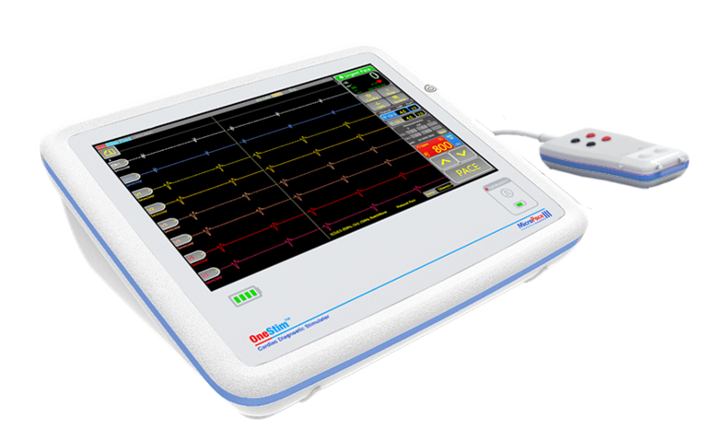

Wake Button

Patient Connection Box

Emergency Pacing Status

Emergency Pacing Channel Outlets

OneStim Console

Battery Status

Figure 1: OneStim Product Appearance

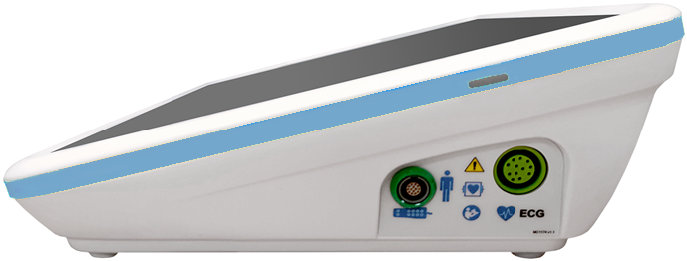

Wake Button

Patient Connection Box Socket

Side Connector PanelSocket

Surface ECG Cable Input

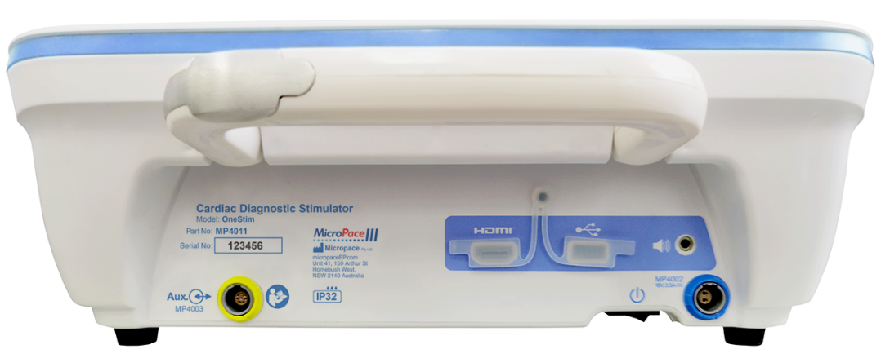

**MP4118**

Device Serial No.

Ext. Auxiliary Signal Connector   
(SIP / SOP)

for Ext. ECG Input

Equipotential Ground

From left to right:

1.Micro HDMI Slave Monitor Output

2.USB 2.0

3.Audio Output

Power Inlet (18VDC)

Master Power Switch

Figure 2: OneStim Product Connection PortsMP4008

## Assembling / installing the OneStim Stimulator Console

* Connect Power Supply to mains power outlet to operate device and charge battery (4 hours to charge fully), or operate device on battery.
* Connect Patient Connection Box to Patient Connection Box socket on OneStim’s Side Connector Panel.
* If a surface ECG trace is required, connect supplied ECG Cable to the ‘ECG’ socket on OneStim’s Side Connector Panel.
* Alternatively, obtain ECG from a 3rd party ECG Monitor signal output via supplied External ECG input Adaptor Cable plugged into the Ext. Auxiliary Signal Connector on the rear.
* The Stimulator is intended to be positioned and operated next to the patient in the Patient Area.

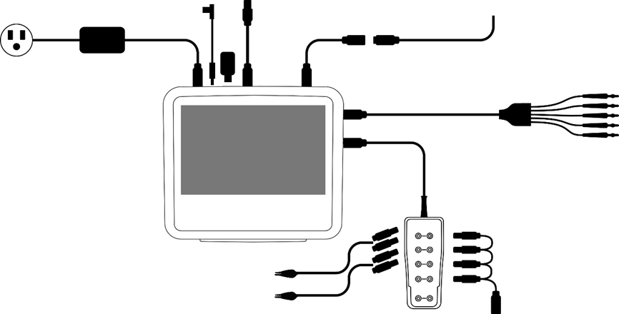

Mains Cable,

MP3059-XX

Power Supply Unit, MP4002

Equipotential Ground Cable   
MP4118

External ECG Input  
Adaptor Cable, MP4003

Ext. Auxiliary SignalConnector

External High Level ECG

ECG Cable,  
MP4108 or MP4105

**OneStim**

**Console**

MP4011

2x HeartWire to 2mm Safety  
Plugs Adapter Cable, MP4008

Unipolar Ref Adaptor,  
MP4085

Patient Connection Box, MP4075

HDMI Cable  
MP4138/40

USB   
Drive

Figure 3: OneStim Components Connection Diagram

## Turning on, verifying and operating device

Switch On Master Power Switch at rear underside of unit; this should be left permanently On unless storing or shipping device, so unit can charge when connected to mains.

OneStim will display POST self-test results on power up. If all battery indicators and Emergency Stimulation LEDs illuminate briefly during the Power On Self-Test and no error messages are displayed then device is ready for use, otherwise refer to Troubleshooting section below.

If more than 6 hours has elapsed since last use, a Safety Message and a dialog box to create New Study number appear.

OneStim enters Sleep Mode and will turn itself Off after a configurable number of minutes. Restore OneStim from Sleep Mode by touching the screen and from Off Mode by pressing the wake button on right side of screen.

## Connecting OneStim to the Patient – PACE Mode

Connect Patient pacemaker lead to Patient Connection Box and to pacemaker PSA and connect ECG leads as required as shown in Figure 4.

PSA Patient Cable

Splitter Cable

TMP or PPM  
pacing lead

Standard ECG Monitoring Electrodes

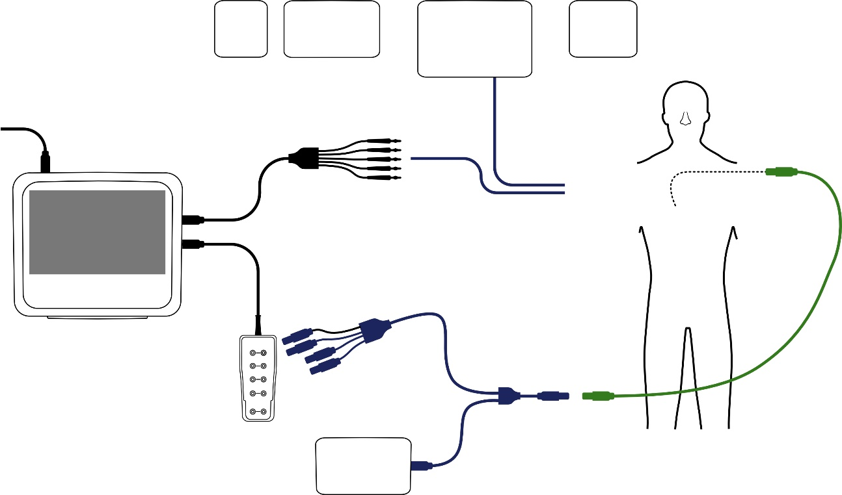

PSA

TPM

DEFIB

ECG Monitor

X-Ray

Temporary Pacemaker

**OneStim**

**Console**

MP4011

OneStim Connection Box

Power Supply

Figure 4: Example of Patient connections to pacing lead

# OneStim Basic Operation

## PACE Mode Main Screen

The OneStim-CRM is a voltage controlled stimulator intended for measurement of cardiac conduction using permanent pacing leads at different locations and intra‑cardiac and surface electrocardiograms, prior to pacing lead implantation.

Features include:

* Stimulation Voltage Control, with limited voltage and current output for compatibility with permanent pacing leads.
* Surface ECG trace display
* Two intra-cardiac channels with a single Pace pacing protocol.
* [Extra-stimulus pacing for refractory measurements]

The Main Screen has the following controls.

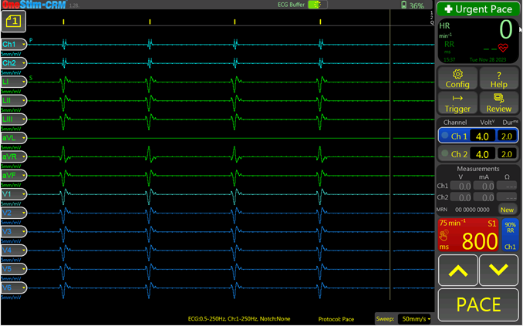

Battery Charge

Configuration,

Help Function,

P/QRS Detect,

Review ECG

Current and Pulse Duration

and Selected Stimulation Channel

Touch for larger measurement window

Trace Sweep Speed

Adjust selected parameter

Start / Stop Pacing

For Urgent Pacing,

press for 3 seconds

Stim and detected QRS indicator trace

Trace Page Menu

ECG Buffer status

Heart Rate

14 Electrogram Traces

Press and hold to access the Stim Protocol menu.

New Study, patient MRN

Set S1 to 90% of RR interval

Figure 5: Main OneStim Touch Screen.

# ECG Signals

## Setting up ECG Sources for display

1. Single-tap the Trace Control Tab to show its menu to select source of ECG and the vertical scale (only one item may be selected from menu at a time).
2. ECG signal may be from:
   * Surface leads (sECG): 5 or 12 Leads if enabled
   * Stimulation channels iECG
   * External High Level ECG input: Ext
3. For External High Level ECG input (e.g. from a bedside ECG Monitor), set Configuration parameter ‘Amplifier gain External ECG’ to the ECG monitor’s gain. (For example, an ECG monitor outputting ±1V signal representing ±1mV ECG, has a gain of 1000x).
4. 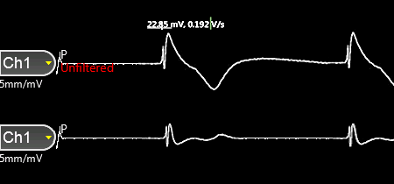Touch and drag ECG handle to move trace up and down.
5. Select Off to turn off ECG trace to reduce screen clutter.
6. ECG Trace colors can be modified in Config H. Trace Colors

## ECG Trace Page Menu

The ECG Trace Page menu allows you to select and save different trace pages. Trace pages allow the user to customise the displayed waveforms, their scale and positions. You can modify, rename and save each of the 5 trace pages.

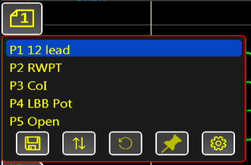

Save Trace Page

Spread Traces evenly

Reset Traces

Show/Hide Template

saved in Review

Trace Configuration Table

ECG traces and pacing events are continuously being stored to a buffer whose length is programmable from 10 to 90 seconds.

## Select Trigger and QRS sensing

1. Select ECG for sensing by Sync or trigger for stimulation by double-tapping the Sense Parameter and selecting channel from menu.
2. The Sensed Display Channel is indicated by an ‘S’ symbol above the channel handle.
3. Note: augmented leads aVL, aVF and aVR can be displayed on screen but cannot be used for sensing.

### Setting Stimulation Sync to ECG

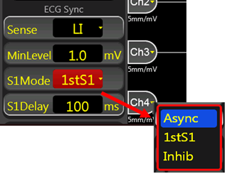Stimulation S1 train by OneStim is asynchronous (VOO or AOO) except for the first S1 stimulus which may be synchronized to the intrinsic electrogram with a set delay, after which pacing is always asynchronous overdrive. Synchronization source is set as follows:

**Sense:** sourceof Sync ECG**:**

1. Select ECG for sync source: Ch1-Ch4, sECG and EXT.
2. An ‘s’ symbol is shown above the sensed ECG Trace Handle.

**S1Mode: Mode** of Stimulation**:**

Select from:

1. **Async**: asynchronous pacing, pacing starts immediately and regardless of patient’s intrinsic ECG activity.
2. **1stS1**: synchronizes onset of pacing (1st S1) to be a set delay after first sensed QRS, following which stimulation is asynchronous (VOO/AOO).
3. **Inhibited**: each S1 is inhibited if earlier QRS is sensed in ECG indicated by Flash “Inhibited”. When inhibited pacing, checks for noise i.e. moving average of HR in last 2 seconds is more than set reversion rate, displays a flash message & reverts to Async.  
     
   Note1: The term ‘QRS’ is used generically to represent any triggering electrogram complex, e.g. in atrial electrogram it would be the ‘A’ wave.

**S1Delay:** In S1Mode 1stS1, sets the delay from electrogram trigger to onset of first S1stimulation.

1. Delay between detected Sync trigger and onset stimulation, i.e. from sensed QRS to the delivery of the first S1 stimulus. (‘S1Delay’ is ignored in Async Mode).
2. Range 10-990ms; Special value 0 sets delay to ‘=S1’.

### Selecting Stimulation Channel

Touch Stimulation channel to select it.

The Channel buttons have Pace indicator LED's at their left border which flash Green when stim delivered, and flash Red when Stim current failed to be delivered, usually due to open pacing circuit.

### Pace On / Off

Press the PACE button briefly to toggle pacing on and off, with button turning red while pacing. A prolonged press, >300ms, will perform as Push to pace, pacing only for the duration of the press.

# Stimulating

## Setting Stimulation Channel, Amplitude and Duration

The required stimulation pulse amplitude and pulse width may be set for each channel,

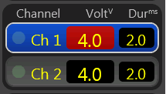In Pace mode, stimulator provides Voltage controlled stimulation.

**Warning:** When using this OneStim to stimulate heart using permanent pacing leads, in order to avoid potential damage to the delicate electrodes, use pulse widths <2.0ms and at no more than 20mA and no more than 8V. Consider using the PACE mode with these limits inbuilt, available in OneStim-CRM or OneStim-Duo models containing these limits.

## Stimulus pulse measurements

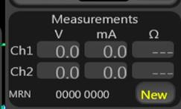In PACE mode, the measurement Panel displays measured resulting stimulation parameters, for each stimulus or averaged for stable readable display.

* V: Voltage, in Volts
* mA: Current, in mA
* Ω: Impedance, (= Volts / mA)

Touching the measurements displays a larger format summary panel, including also A / V wave amplitude and dV/dT.

# Performing Diagnostic Stimulation

## Pacing Protocols

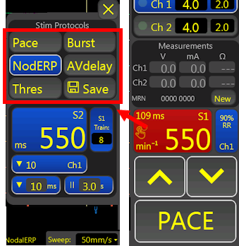

Pacing Protocol menu may be displayed by prolonged press of S1 button, containing the following protocols:

**Pace:** Default regular pacing also performed when no Pacing Protocol Menu is displayed, with default S1 lower limit of 300 ms, configurable down to 280ms.

**Burst Pace:** Rapid Pacing with default lower limit of 240 ms, configurable down to 100ms.

**NodERP:** ‘Nodal ERP’ single S2 extra-stimulus protocol. Set Train for number of S1 in train and set Pause to required pause in seconds between Train repetitions; set Pause to 0 for no repetition. The down arrow sets the automatic decrementation of S2 between train repetitions, default 10ms.

**AVDelay:** A-V pacing with S2 A-V delay. If S1Mode is set to Inhibited, then sensing is automatically set to Atrium only and cannot be changed.

**Thres:** The 'Threshold' protocol aids in establishing the pacing threshold for all protocols by initiating pacing and then gradually reducing the pacing amplitude. The operator needs to halt pacing when capture is lost after which it may be fine tuned manually. Adjust Train parameter adjust speed of reducing current.

Icons:  = Pause,  = S2 Decrement.

## Urgent Pace

For urgent physiological pacing, no matter which protocol and what parameters are set at the time, press and hold ‘Urgent Pace’ **for** **3 seconds** – OneStim will enter Urgent Pace Protocol, stimulating at 600ms into all channels at a higher current.

Select any Protocol to exit this mode.

Note: this is distinct from independent separate battery powered Emergency Pace Output (EPO) described below.

**W8 Warning:** Urgent Pacing is not intended or approved for life support pacing and is intended only for brief pacing to support blood pressure while a temporary pacemaker is retrieved and connected to the patient requiring life supporting pacing.

# QRS /Trigger Submenu

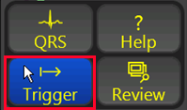This menu provides navigation to Configuration and Help pages and QRS display in a triggered sweep page. QRS Detection menu allows synchronization of start of pacing to sensed ECG as in EP Mode.

## QRS Detection

QRS Detection page shows magnified ECG with indication of the ECG Complex detection algorithm (generically referred to as ‘QRS’).

QRS detection threshold is dynamic, as in permanent pacemakers, and performance may be adjusted by MinLevel threshold, Polarity, Blanking period, Post Blank threshold reduction by % and inter-complex Decay of Threshold value.

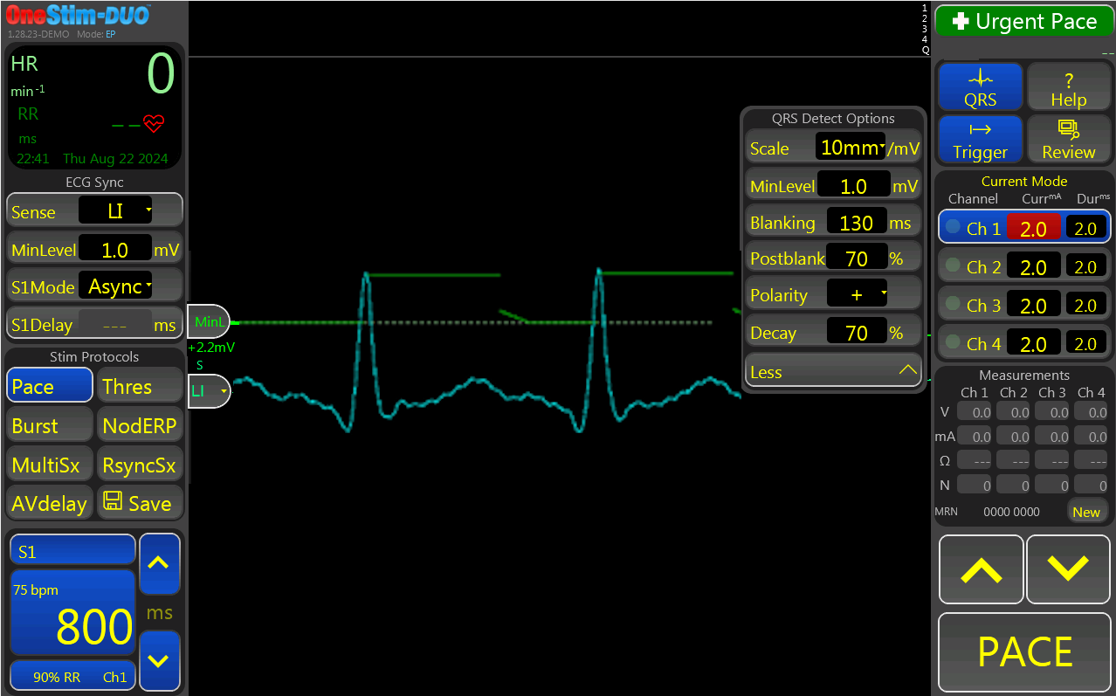 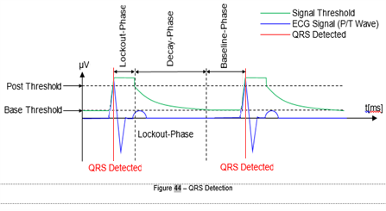

Figure 6: QRS Detect Menu (MinLevel = Minimum Threshold)

## Trigger Page

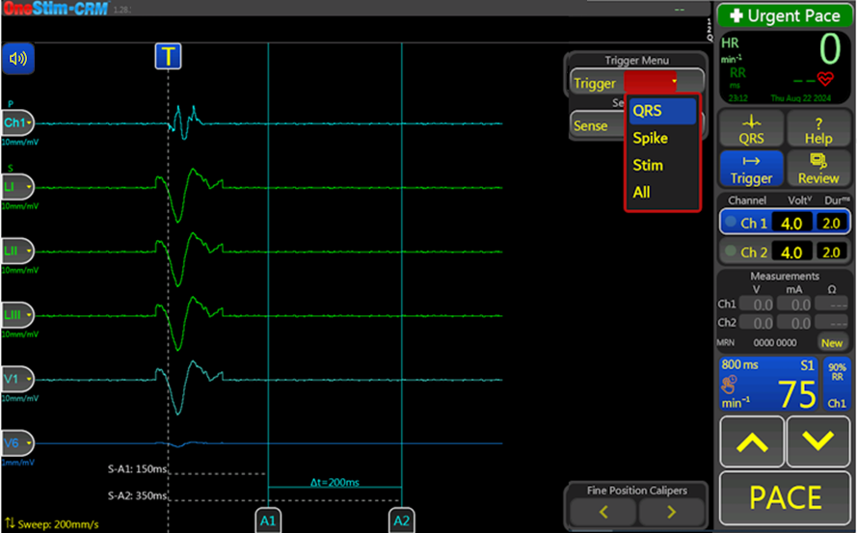

Cursor Measurements

Caliper fine movement control

**Trigger:**

- QRS,

- Spike,

- Stim

- All

QRS Tone

Pause/

Play

Figure 7: Triggered Sweep page

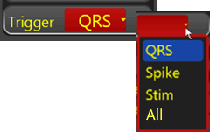The QRS may be examined during intrinsic or paced rhythm in this mode, triggering the sweep on one of three triggers:

1. **QRS**: Detected QRS (first peak)
2. **Spike**: Pacemaker Spike (External PPM or PSA)
3. **Stim**: OneStim pacing stimulus
4. **All**: Any above events will trigger

The Page provides three measurements in milliseconds:

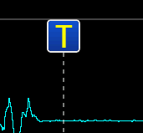

1. **S-A1:** From Trigger (Spike or Stim) to A1 Cursor
2. **S-A2:** From Trigger (Spike or Stim) to A2 Cursor
3. **Δt:** Time difference between A1 and A2 cursors

**Pause / Go button**

This control “T” pauses and restart the triggering of display.

# Help Menu

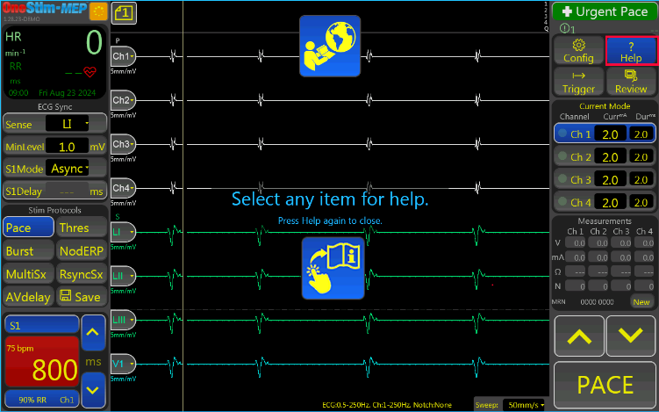To obtain help information on parameters, press the ‘Help’ icon and then click the element for which help is required.

For example, to get help on Ch1 Current

Multi-language User Instruction manual

parameter, press ‘Help’.

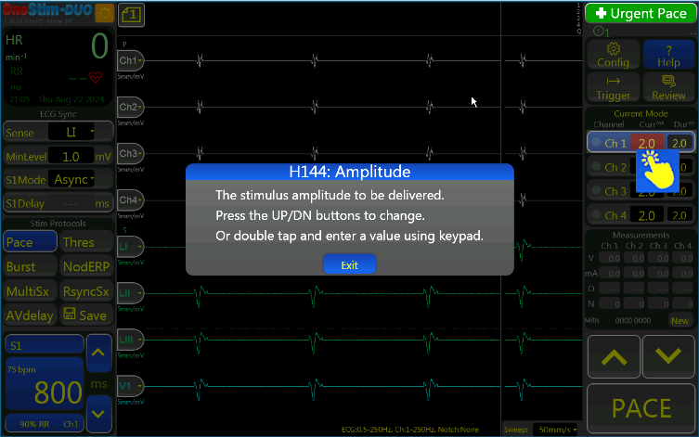Then touch the Ch1 Current field:

Press the Book Icon at the top for multi-lingual User Instruction manual.

# Reviewing and Saving ECG

The Review Page selected by ‘Review’ button is used to review and export events of interest from the study.

## Signal Review Page

Captured ECG may now be reviewed and analysed. Position and size of traces on the screen may be adjusted by:

* Swiping left or right on the trace to pan sideways.
* Swiping up or down to change sweep speed.
* Sliding the trace control buttons on the left side of the screen upwards or downwards.
* Tapping on the trace control button and choosing the channel or scale you wish to display.

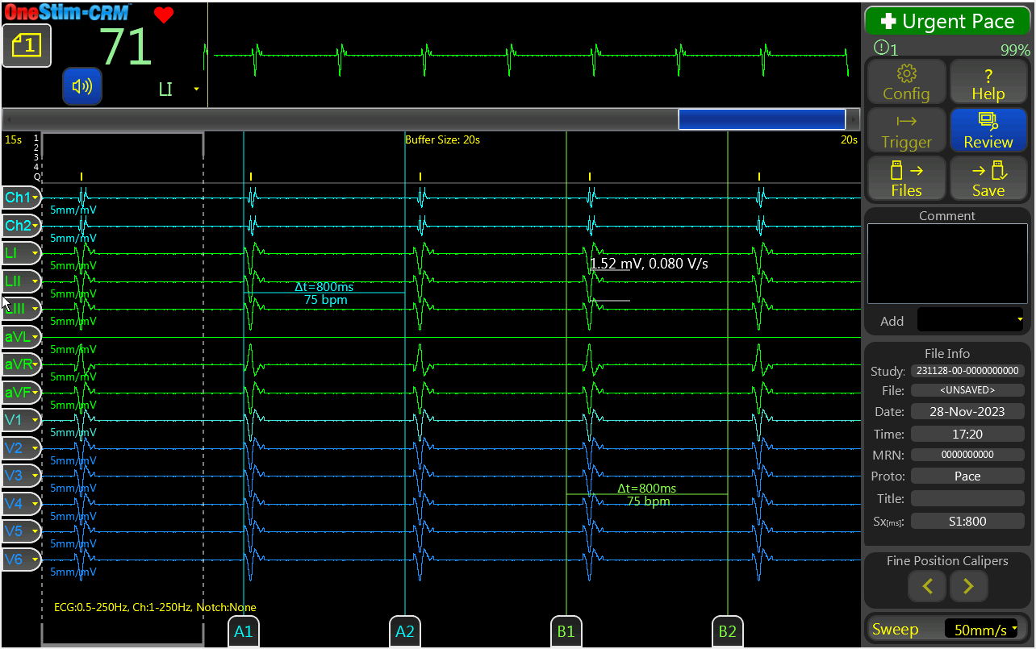

Swipe: pans

Swipe:

scales

Amplitude Measurement

Figure 8: Review Screen with Time callipers and amplitude calliper (circled).

Electrogram size and timing may be measured as follows:

Touching the electrogram feature will show the amplitude (red circled -



Swipe: pans

Swipe:

scales

Amplitude Measurement

* Figure 8).
* Sliding time Calliper pairs A1 & A2 and B1 & B2 will measure time intervals; use  and  buttons for fine adjustment.

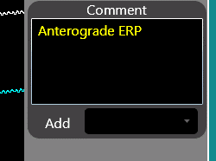

A legend or comments may be added to the file via the Comment box and will appear on top of the PDF printout.

## Review Template / Freeze column

On the review page, OneStim allows users to save the leftmost traces as a template.

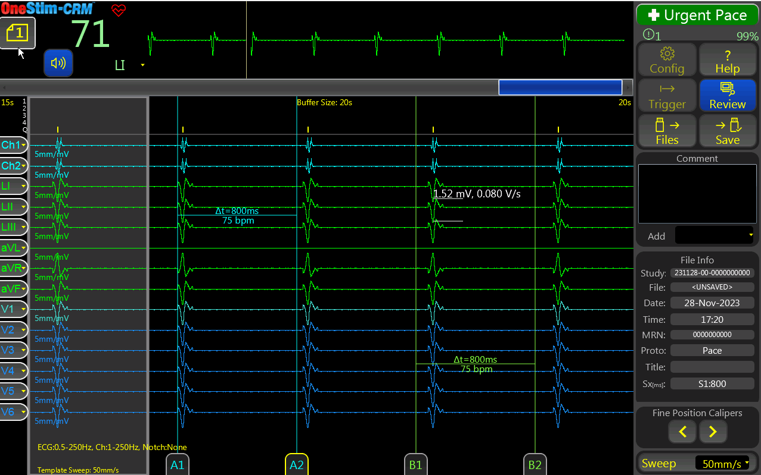

Figure 9: Review Template/Freeze column

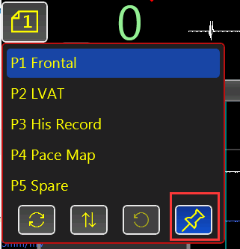

* Pressing the 'PIN' icon in the Trace Page menu freezes the leftmost area of ECG indicated by dashed line as a Template. Press icon again to delete template.
* The saved Template may be displayed in the Live Screen by the ‘PIN’ icon in its Trace Page menu. Press icon again to hide template.
* ECG Leads but not sweep speed may be changed in the Template.
* ‘Freezed’ column follows changes of trace selection, trace position, scale and page on review page.

On the main page, users can load/hide the last saved ‘freeze column’ from trace page menu.

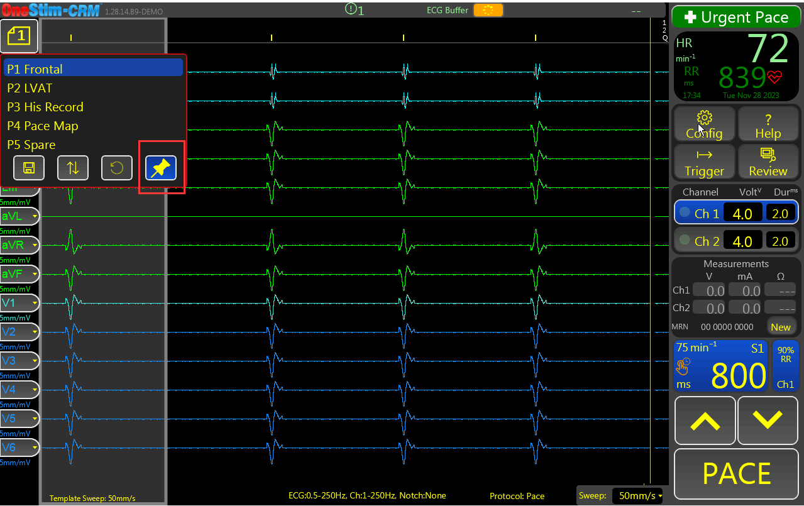

Figure 10: Load Freezed Column on the main page

## Saving and Recalling Data

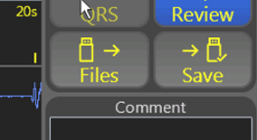The SAVE button will save review data to an inserted USB Drive (format must be FAT32), or if absent, then to internal storage. The complete ECG buffer data along with Date/Time, the last Stimulation protocol and entered Comments are saved and the visible screen is also saved as a printable PDF file.

A Study is auto-created from the current Study Number and files numbered sequentially and with last Protocol name and first few characters of any Comment.

The File Manager shows content of OneStim internal storage or inserted USB drive with studies on the left panel and their files on the right.

Individual files may be loaded for review.

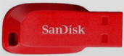Single or multiple studies or files may be exported to USB drive, loaded from USB Drive or deleted.

Note: ‘Sandisk’ brand USB drives are recommended for compatibility, e.g. Cruzer Blade. Some other brands may fail to be detected. Format must be FAT32.

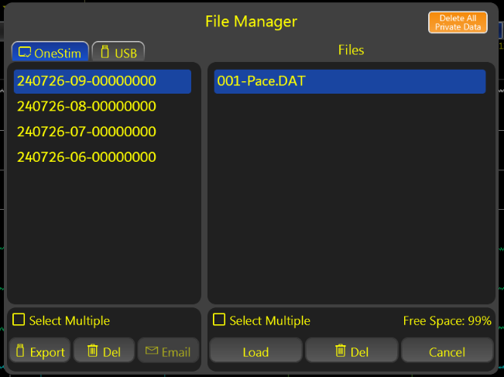

Figure 11: Study and File recall and management

## Printing

PDF files saved on the USB drive may be printed Full 1:1 scale to A4 or Letter format paper from any computer with suitable PDF software.

Retained records should be suitably and securely identified to the patient, such in the Hospital Information System or with an applied ‘Hospital ID sticker’ if printed.

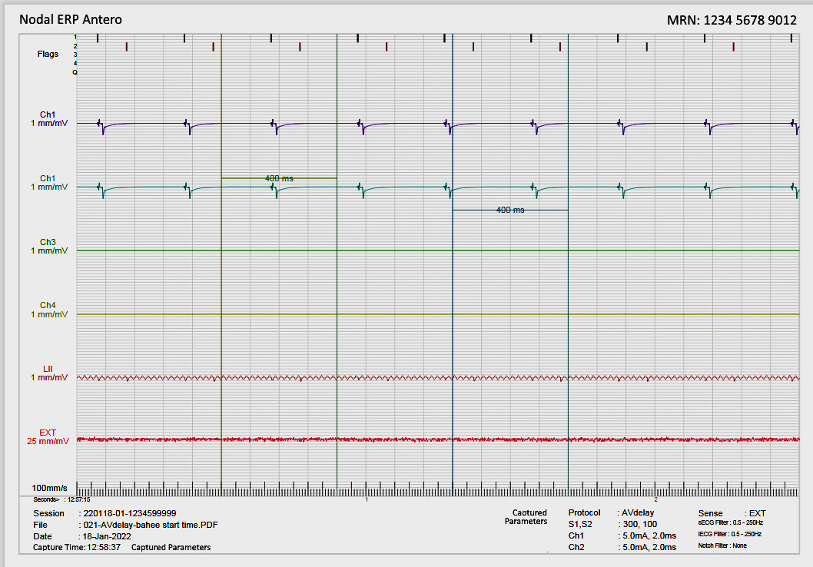

Figure 12: Example of ECG PDF Printout

# Using the Emergency Pacing Output (EPO)

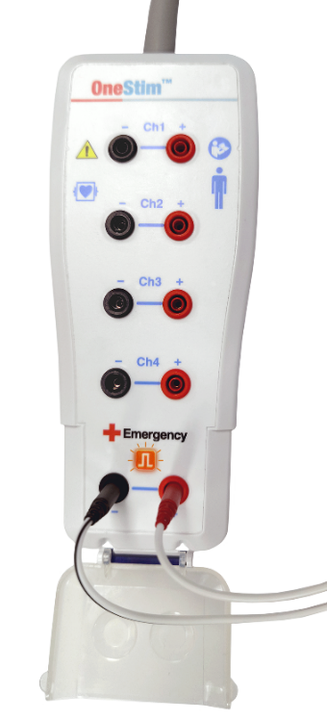

2. Move pacing leads to Emergency Channel

3. Pacing starts automatically, orange light flashes

1. Forcefully open cover

Emergency Pacing Output (EPO) is an independently battery powered emergency pacing output which remains available even if OneStim becomes inoperable due to device failure or depleted battery. On connection of pacing output to intra-cardiac pacing lead, EPO detects connection and immediately starts pacing at a fixed 100ppm / 8mA / 2ms.

**W9 Warning:** The Stimulator’s Emergency Pace outlet is not for life support and may be used to pace a bradycardic or asystolic patient to maintain haemodynamic stability for the few seconds while retrieving and connecting a temporary external pacemaker. Emergency stimulation at 100ppm / 8mA starts automatically on connection to intra-cardiac leads (impedance

< 50kΩ).

Figure 13: Emergency Stimulation Channel connection.

To use, open the clear cover on the Patient Connection Box and connect to patient’s ventricular pacing lead. Stimulation commences immediately on connection and will be indicated by flashing orange pulse between the Emergency Channel connectors and also at the OneStim Console at the right lower area titled Emergency. Use EPO only until the pacing can be changed to an approved temporary external pacemaker. The EPO battery has a shelf life of 10 years and provides more than 8 hours of pacing. Battery charge adequacy is verified at device power on tests; battery depletion while pacing is signalled pacing at half rate, i.e. 50 min-1.

# Device Configuration

The device may be configured in the Configuration Menu. Refer to the Help Menu.

Allows configuration of Background Parameters related to Basic Operation, including idle and sleep timeouts, ECG Settings, Stimulation Settings and Advanced Settings.

Config menu can be protected by enabling password (fixed to 7845) in basic menu.

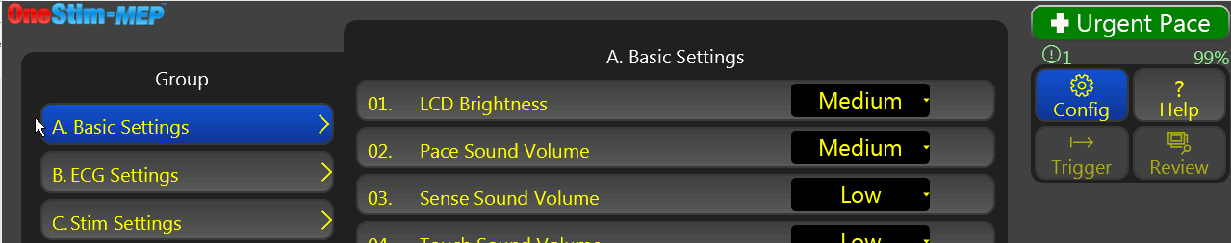

# Troubleshooting

| **Problem** | **Solution** |
| --- | --- |
| OneStim is unresponsive when I press the ON (Sleep/Wake) button on the right hand side. | 1. Ensure that device is switched ON at the Power Switch on the rear–underside of device. |
| 1. Battery may be depleted - connect to external power supply and try again. |
| OneStim is stimulating, but the patient’s heart is not capturing. | 1. Verify that the correct channel is being paced. |
| 1. Verify that the pacing circuit is complete. |
| 1. The LED next to the Pace Channel Current Setting button should flash green, if it flashes red, then the circuit is incomplete and all connections to the patient need to be checked. |
| 1. Check the Pacing impedance – in the Measurements section, indicated next to the Ohm (Ω) symbol for the paced channel. It should be between 300 and 1200 Ω for the intra-cardiac and between 500 and 2500 Ω for the oesophageal pacing route. |
| 1. Check the position of the pacing lead in relation to the heart – preferably on an X-ray. |
| OneStim’s display is frozen or OneStim starts beeping irregularly on start-up and responds erratically to touch | 1. Restart the device by switching the Power Switch on the rear-underside of the device to Off and On, while making sure that nothing is touching the screen during start‑up, as this will interfere with self-calibration of the touch screen. |
| The Emergency Stimulation does not work. | 1. The Emergency Stimulation starts pacing automatically when it senses a conduction path of an intra-cardiac pacing catheter connected to its outputs (<50 kΩ) |
| 1. Test Emergency Stimulation by inserting the Micropace Test LED, MP3058, or by shorting outputs with a conductor (paper clip will do) – expect a tone and Pulse light on the Patients Connection Box to flash at 100ppm. |
| The On-screen Battery Indicator has a small cross on it or has incorrect charge indication, e.g. the device powers off at 20% charge. | 1. This normally occurs for several charge & discharge cycles after replacement of a battery, until the fuel gauge ‘learns’ the new battery. If the issue persists contact service. |
| 1. If the battery has not been changed recently, this may indicate the End of Life or a faulty battery. |
| While pacing, pacing sounds are irregular and ECG display sweep pauses for a second. | 1. Occasional delays in display are normal and do not interfere with pacing, which remains regular and accurate within ±1ms. |

Figure 14: Troubleshooting

# Software Warning / Error Messages

## Flash Messages

OneStim issues brief 5 second advisory ‘Flash Messages’ in the middle of the screen.

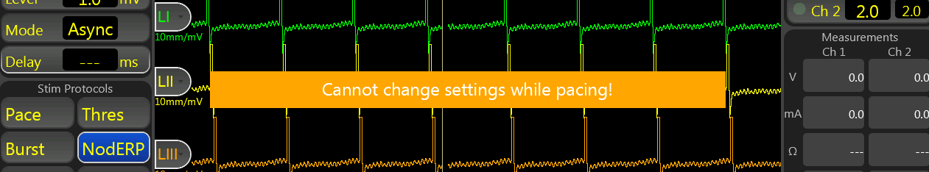

These messages are self-explanatory, examples include:

|  |  |
| --- | --- |
| **Flash Message** | **Meaning & Action** |
| F12: Cannot change settings while pacing! | You must stop pacing before changing some parameters, such as those in the Configuration Menu. |
| F17: Cannot change protocol while pacing! | Stop pacing before changing stimulation protocol. |
| F18: Lower Limit: [number] | Enter a value within stated limits. |
| F35: Waiting for QRS Sync... | Start of stimulation is synchronized to ECG (Mode: 1stS1); waiting for ECG trigger to start pacing. |
| F49: QRS Sync Timeout! Pacing... | No ECG sync trigger came within safety timeout, (set by config (51) "QRS Sync Timeout") so pacing started anyway. Ensure adequate ECG trigger when enabling Sync Mode. |
| F37: Open Circuit ChX, Check leads | The stimulator detected an open circuit in the stated channel – check leads. |
| F38: High ChX Impedance | The stated channel has unusually high impedance (>2000Ω) – check leads. |
| F39: Short Circuit ChX, Check leads | The OneStim detected a short circuit in the stated channel – check leads. |
| F40: Low ChX Impedance | The stated channel has unusually Low impedance (<200Ω). – check leads. |
| F44: Battery Low! Connect to mains power | The battery is below 20%. Connect to mains power. |
| F46: Device not for life support pacing, use Temporary Pacemaker! | The OneStim has been pacing unattended for >2 minutes without diagnostic manoeuvres. The OneStim is for diagnostic use and not for life support pacing. If patient needs cardiac pacing for bradycardia, use temporary pacemaker. |
| F27: Device is not for ECG Monitoring and will shortly go to sleep..  (Device not for use as ECG Monitor) | After 2 minutes in idle safety state, OneStim enters power saving standby mode (on battery and on Mains). Device is not intended for nor safe for ECG Monitoring. |

# Maintenance

## Batteries

Internal main rechargeable LiFePO4 battery and 9V Emergency Stimulation Battery are located on the underside of the device. Labels indicate the replacement date. For optimal battery life, operate device on battery power until fully discharged at least once a month.

**W10 Warning:** In order to avoid the remote possibility of the lithium battery overheating and causing a fire,

1. Do not charge battery other than inside OneStim.
2. Do not puncture or incinerate; dispose of as below.
3. Only replace by service staff with Micropace replacement part specified on battery cover.

## Maintenance and Calibration

1. Suggested weekly preventative servicing:

* Inspect, clean and check the screen for correct operation when powered on.
* Inspect all cables and connectors for damage – such as crushing or fraying.
* Check integrity of enclosure anti-tampering seal under the handle.

1. Suggested annual additional preventative servicing:

* Check battery replacement due date on underside of the OneStim.
* Check that fan operates briefly at power switch on; verify outward air flow by a tissue hung in front of the vents on the left side of the device.
* Check calibration of Emergency Stimulation output to be ≥ 8V into 1 kΩ load.
* Check calibration of Ch1-4 stim outputs into 1 kΩ load as per specifications.
* OneStim self-calibrates. If found to be out-of-calibration, request factory service.
* Perform electrical safety tests to IEC60601-1 /UL2601-1 using a suitable commercial tester, particularly leakage currents, especially if OneStim is connected to IT equipment such as a printer via USB or to a display via HDMI.

## Cleaning Instructions

1. The stimulator parts may be cleaned using a cloth dampened with hospital equipment cleaning agents such as isopropyl alcohol (IPA), ethanol or mild soap. Do not spray or pour agents onto the equipment and do not use acetone solvents.
2. To clean the touch screen, use window or glass cleaner.
3. If using OneStim in ICU wards and also in operating rooms, take special care to avoid transfer of ICU pathogens into the operating room – clean device thoroughly and consider wrapping in sterile plastic bag. Ideally, also consider having a dedicated OneStim device for operating rooms.

## Service, Serviceable Life and Disposal

1. The OneStim system has no user serviceable parts apart from its two batteries and has an expected supported service life of 5 years.
2. Dispose of the LiFePO4 battery in an approved disposal or recycling facility.
3. P12 Dispose of OneStim separately from household waste according to EU WEEE legislation – contact the distributor or Micropace for assistance.
4. Further technical and service support information is available by request at [micropaceep.com](http://www.micropace.com.au).
5. P11: Where possible, remove any study data from OneStim device prior to shipment for service or disposal.

# Explanation of Symbols

| **Location** | **Symbol** | **Name** | **Meaning** |
| --- | --- | --- | --- |
| On device side connector |  | Requirement to refer to instructions for use | Requirement to refer to instructions for use prior to use. |
|  | General warning sign | To signify a general warning |
|  | Type CF defibrillator proof | To identify a defibrillation-proof type CF applied part complying with IEC 60601-1 |
|  | Patient applied parts connections | To indicate the two connections to the patient from the side panel of the OneStim console |
|  | ECG cable connection point | Indicates the location of the ECG cable connection socket |
|  | Connection for patient connection box | Indicates the location of the socket for the Patient Connection Box cable |
| On front panel of device | Battery,-general | Battery power | To identify the power supplies status from the battery.  On the left side, the image is backlit in 4 sections, indicating the power remaining in the battery.  On the right side, image is green for nominal charge and red for depleted state. |
|  | On / off / sleep | Indicates the push button on side of device for On/Off/Sleep functions |
| On rear panel |  | General warning sign | General warning sign |
| 0 / I | Power  OFF / ON | Device is switched OFF and battery is NOT charging or device is ON and Battery Charging |
| **HDMI** | HDMI video output | External Monitor Output |
| **Aux** | Input / output Auxiliary Port | Auxiliary Connector for high level ECG signal input and output |
|  | Speaker output | High level speaker output to external speakers  **Note:** The OneStim also contains an internal speaker to allow for communicating operational states |
|  | USB | USB connector |
|  | Equipotential Earth | Equipotential earthing socket for optional use with MP4118 Cable to connect to Hospital POAG (Potential Equalisation) socket. Intended for reduction of electrical signal interference noise; not for protective earthing; max current 0.5A. |
| On underside of device |  | Rechargable battery location | Indicates the location of the main rechargable battery |
|  | 9V battery | Indicates the location for the 9 volt battery for emergency stimulation |
|  | Crossed-out wheeled bin | Do not dispose in general household waste |
| General-symbol-for-recovery/recyclable | General symbol for recovery/ recyclable | To indicate that the rechargeable battery and its material is part of a recovery or recycling process. |
| On patient connection box |  | Requirement to refer to instructions for use | Requirement to refer to instructions for use prior to use. |
|  | Pace | Emergency channel stimulation |
| On patient connection box |  | Positive Output | Positive stimulus output |
| On patient connection box |  | Negative Output | Negative stimulus output |
| On patient connection box | Ch1 – Ch4 | Ch1-Ch2  or  Ch1-Ch4 | Stimulation channel outputs |
| On medical device product/shippinglabel. |  | Manufacturer | Legal manufacturer |
|  | Date of  Manufacture | Indicates the date when the medical device was manufactured |
|  | Country of Origin | Indicates country of origin being Australia |
|  | EC Rep | European representative |
|  | UKRP | UK Responsible Person |
|  | Catalogue No.  Serial No.  Lot No. | Catalogue Reference Number  Product Serial Number  Product Lot Number |
| ISO 15223:2020 Update of for Symbols to be used with ... | Distributor | Distributor of product |
| ISO 15223:2020 Update of for Symbols to be used with ... | Importer | Importer of product |
|  | Read Instruction for Use | Refer to Instruction for Use |
|  | Is a Part of | Item is a part of named product |
| On Rear of Device and On Power Supply Unit |  | Alternating current  Direct current | Alternating current  Direct current |
| On Power Supply Unit | **IP22** | Ingress protection | Protected from touch by fingers larger than 12 millimeters.  Protected from water spray less than 15 degrees from vertical |
|  | Indoor, dry location use only | For use indoor or dry locations only |
|  | Consult Instructions for use | Indicates the need for the user to  consult the instructions for use |
| On Package Shipping Label |  | Temperature limit | Harmonized symbol for temperature limit  -10°C to +60°C |
|  | Humidity limit | Harmonized symbol for Humidity from 10% to 85% RH |
| HDMI cable | C:\Users\j.greifeneder\AppData\Local\Packages\Microsoft.Windows.Photos_8wekyb3d8bbwe\TempState\ShareServiceTempFolder\Monitor_Icon.jpeg | Video display | Connect cable to video display |

Table 3: Meaning of symbols on device

# Electromagnetic Interference (EMI) and Compatibility

## EMI Warnings

This device is suitable for use in hospital environments only. It may be used in conjunction with RF ablation and surgical diathermy instruments.

This device is not rated for use in the vicinity of MRI equipment.

**WARNING:** Strong electromagnetic interference may cause corruption or loss of ECG trace and might cause erratic or un-programmed stimulation which may or may not be apparent on displayed ECG. In case of unexpected or erratic pacing by this device, inability to stop pacing via touch screen, or in case of defibrillator-resistant ventricular arrhythmias, immediately disconnect patient from this device and do not use device until serviced.

**WARNING:** The device should not be used adjacent to or stacked with other equipment. If adjacent or stacked use is necessary, the device should be observed to verify normal operation in the configuration in which it will be used.

**WARNING:** Use of accessories, transducers and cables other than those specified or provided by the manufacturer of this equipment could result in increased electromagnetic emissions or decreased electromagnetic immunity of this equipment and result in improper operation.

**WARNING:** Portable RF communications equipment (including peripherals such as antenna cables and external antennas) should be used no closer than 30 cm (12”) to any part of this device, including cables specified by the manufacturer. Otherwise, degradation of the performance of this equipment could result.

**WARNING:** This equipment/system is intended for use by healthcare professionals only. This equipmen system may cause radio interference or may disrupt the operation of nearby equipment. It may be necessary to take mitigation measures, such as re-orienting or relocating the device or shielding the location.

## Cable Lengths

OneStim with the cables and cable lengths listd in section 4.1 above comply with:

* Emissions CISPR 11, Class A / Group 1
* EN 60601-1-2: 2014

WARNING: The use of accessories or cables other than those specified may result in increased emission and/or abnormal function of the Micropace Stimulator.

## EMI / EMC Specifications - Summary

OneStim was tested according to IEC 60601-1-2:2014 guided by TR 60601-4-2:2016.

For details, refer to OneStim Technical Service Manual.

|  |  |  |
| --- | --- | --- |
| **Emissions test** | **Compliance** | **Electromagnetic environment—guidance** |
| RF emissions CISPR 11 | Group 1 | OneStim uses RF energy only for its internal function. Therefore, its RF emissions are very low and are not likely to cause any interference in nearby electronic equipment. |
| RF emissions CISPR 11 | Class A | OneStim is suitable for use in all establishments other than domestic and those directly connected to the public low-voltage network that supplies buildings used for domestic purposes. |
| Harmonic Emissions IEC 61000-3-2 | Class A |
| Voltage Fluctuations / Flicker Emissions IEC 61000-3-3 | Complies |

| **Immunity test** | **IEC 60601 test level** | **Compliance** |
| --- | --- | --- |
| Electrostatic discharge (ESD)  IEC 61000-4-2 | Level, 4 ± 8 kV contact  ± 15 kV air | Complies |
| Electrical fast transient/burst  IEC 61000-4-4 | ± 2 kV for power supply lines  ± 1 kV for input/ output lines | Complies |
| Surge IEC 61000-4-5 | ± 1 kV differential mode  ± 2 kV common mode | Complies |
| Voltage dips, variations, short interruptions on power supply input IEC 61000-4-11 | Per standard | Complies |
| Power frequency (50/60 Hz) magnetic field IEC 61000-4-8 | 30 A/m | Complies |
| Conducted RF IEC 61000-4-6 | 3 Vrms 150 kHz to 80 MHz | Complies |
| Radiated RF IEC 61000-4-3 | 3 V/m 80 MHz to 2.5 GHz | Complies |

# OneStim Specifications

## General

Specifications V1.5

|  |  |
| --- | --- |
| **Parameter** | **Value** |
| Power Source | Input Class I, 100-240VAC to 18V 60W medical grade Power Supply |
| Rechargeable Battery, LiFePO4, 4S2P 12.8V 38.4Wh |
| Power Consumption | Normal operation: 15W Average  Sleep Mode: < 0.5W |
| Operating time on battery | 2 hours continuous  8 hours typical use (sleep after 3 min idle) |
| IPXX Rating | None. Protected according to IEC60601-1. Refer to Technical Manual for detail. |
| Applied Parts Classification | sECG and Stimulation Outputs: Class CF, Defibrillation proof. |
| Display Resolution | HD 1280 x 800 pixels |
| USB Port | USB 2.0, compatible with Sandisk drives |
| Weight / Dimensions | 3.7 kg (4.55 kg with accessories) / 33 cm x 12 cm x 29 cm |
| Environmental | Operating T° Range: +5ºC to +35ºC (30% to 80% RH)  Storage T° Range: -10ºC to +60ºC (10% to 85% RH)  Altitude (transport): 0 to 14,000ft (4,267m) |

## Stimulation Electrical Specifications

| **Stimulation Parameter** | **Value** |
| --- | --- |
| Stimulation Channels | 2 (PACE Mode) |
| 1 Emergency Pace Output (EPO) 100ppm / 8mA nominal |
| Stimulation Circuit Isolation | Type CF, IEC60601-1, CM 5kV, DM 500V energy attenuating, |
| Voltage Range | 0.1 to 8V, max 25mA (PACE Mode) |
| Pulse waveform | Monophasic (Mono) with charge recovery. |
| Pulse duration | 0.1 to 2ms (Pace Mode) |

## Stimulation Timing Specifications

| **Pacing Parameter** | **Value** |
| --- | --- |
| S1 | 300 - 5000 ms in Pace Protocol, 10ms step  100 - 5000 ms in Burst Protocol, 10ms step |
| Extra-stimuli | S2 (PACE Mode) |
| S2 interval | 30 - 990 ms |

## Intra-cardiac iECG Specifications

| **iECG Sensing Parameter** | **Value** |
| --- | --- |
| Channels | Equal to Stimulation Channels |
| Input ranges (FSD) | ±1 mV to ±16.5 mV |
| Common Mode Range | ±0.3V |
| Software display sweep speeds | 10, 25, 50, 100, 200 mm/s (additional 2, 5, and 400 mm/s in the review screen and PDF printout) |
| Frequency Filter Settings | HPF: 0.5, 1, 5, 30 (default) Hz  LPF: 250 (default), 500 Hz  Individual Trace Control: Filtered: 30Hz / Unfiltered: 0.5Hz |
| Input impedance | 60 KΩ (pacing charge dissipating) |
| Input CMRR | >80 dB |
| iECG Sampling: | 1000Hz, 16-bit, 50 uV/bit based on 3.3V full-scale |
| Pacing Impedance Measure | Range: 50 Ω ('<50') to 9000 Ω ('> 9k') |
| Defibrillation Recovery Time | < 5 seconds |

## sECG Specifications

|  |  |
| --- | --- |
| **sECG Sensing** | **Value** |
| Leads | Standard 5 or 12 Lead sECG |
| Input ranges | ±10 mV |
| ECG display amplitude scales | 1, 2, 5, 10, 25 mm/mV |
| ECG display sweep speeds | 10, 25, 50, 100, 200 mm/s (& 400 mm/s in review screen) |
| Input impedance | >1 GΩ |
| Input CMRR | 90 dB |
| SECG Sampling | 1000 Hz, 16-bit, 50 uV/bit based on 3.3V full-scale |
| Defibrillation Recovery Time | < 5 seconds |

## Ext. Input ECG Specifications

| **Extern. ECG Sensing** | **Value** |
| --- | --- |
| Inputs | One, galvanically isolated to 1.5kV |
| Input ranges | ±1V Accuracy ±10% |
| External ECG Amplifier Gain | 1 to 250 |
| Frequency Range(-3dB) | 0.5 Hz to 250 Hz nominal |

## ECG Notch Filter

|  |  |
| --- | --- |
| **ECG Notch Filter** | **Value** |
| Channels | When enabled applies to sECG, iECG and Ext. |
| Notch Frequency | Selectable 50Hz / 60Hz |

## Emergency Stimulation Channel

|  |  |
| --- | --- |
| **Emergency Stimulator** | **Value** |
| Power | 9V LiMn Battery, 10 year standby life, >12 hours operation |
| Pacing Activation | Activated by connection to intra-corporal pacing electrode pair (activating impedance <50 kΩ approximate) |
| Pacing Parameters | 100ppm, 8mA (+1/-3 mA), up to 8V, 2ms pulse duration |
| Warnings | Low Battery: Red battery LED & Pacing rate falls to 50 min-1  Disconnection: 3 seconds long pacing sound |